#1 Check threshold-

Destiny hasn’t received any emails/alerts from his security system that was installed weeks ago. Being a pessimist Destiny thinks this is a mistake. He decides to drive to his rental property to check out the system. He knows that there are deer and dogs that walk around his property and wants to be alerted to these.

Destiny logs into the computer to get access to the monitoring system. After pulling up the system tab Destiny checks to make sure his email is entered into the system. It is. He then checks to see if any video has been recorded. None has. Next he remembers that there is a threshold meter. He checks the threshold and finds it to be at the highest setting. Destiny lowers the threshold to a little under half way. He realizes that this must have been his problem.

#2 Setup system

Destiny just purchased a new motion detecting security system. It has already been installed on his laptop, and he just needs to get all the options set to his preference. The area he will be monitoring has a lot of animal activity. This is not activity he wants recorded. He only wants larger disruption to be captured, and then receive an alert.

Destiny is at his laptop looking at the system. He pulls up the security system window. He decides to first choose his threshold. He looks at the options and decides to set the threshold to 4. He then enters his email for alerts. And finally sets the time-threshold

Requirement Statement 1

1. Program will run from an executable.
2. Can get real-time images from webcam.
3. Stores the initial image as a constant upon start-up.
4. Determines if motion is detected by comparing pixel difference between constant and current image.
5. The system can store multiple email addresses separated by commas.
6. Send email to stored emails addresses if motion has been detected.
7. Email will contain date, time, alert level.
8. Alert level is based on amount of time spent recording.
9. Threshold meter ranging from 0-10( per 10% of pixels changed) for disruption in picture.
10. Threshold meter ranging from 0-10( per 10% of an hour) for maximum time of recording.
11. When motion is detected, system saves each image containing disruption.
12. Can convert the list of images into a video.
13. Video is uploaded to dropbox account.

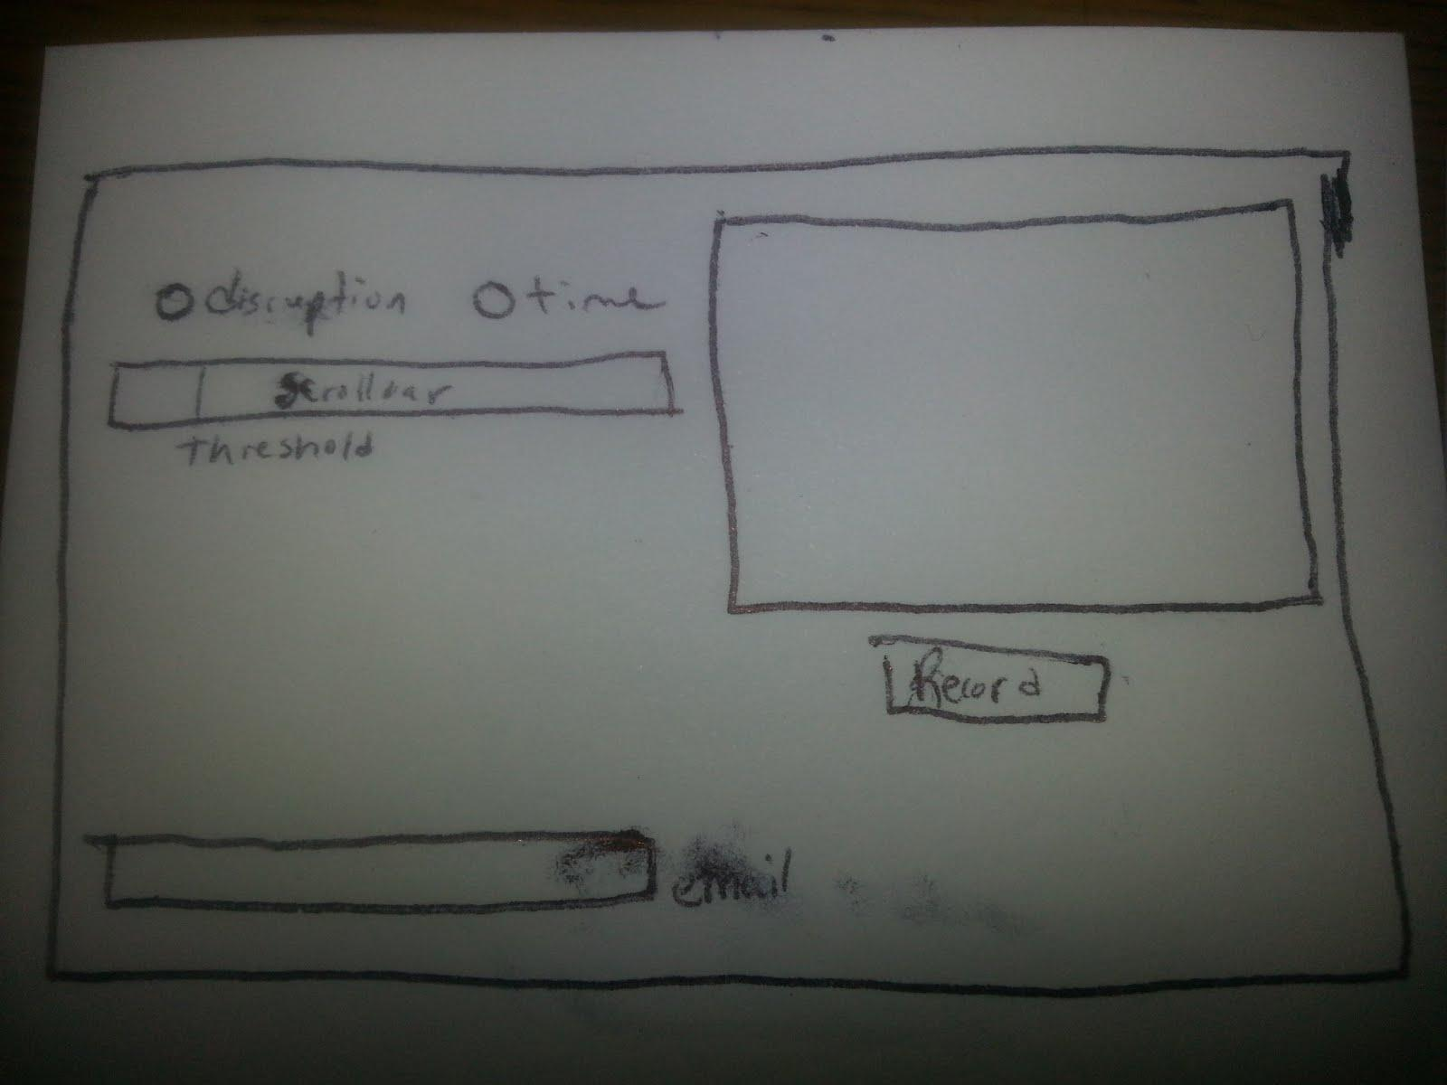

1. Should allow you to enter an email address, or many
2. Will display an up-to-date image of webcam feed.
3. Shall provide a way to start recording
4. Shall provide a way to update ‘base’ image.
5. Threshold meter ranging from 0-10( per 10% of pixels changed) for disruption in picture.
6. Threshold meter ranging from 0-10( per 10% of an hour) for maximum time of recording.
7. Can stop recording at any time.
8. The base image of the system shall be updated every 10 minutes to account for daylight shifts.

For my requirement statements I decided on a 10 minute delay before updating the base image in the system. This, I think, is a strength to the program. This, as opposed to taking an image, then a new image, compare the two and if there was no motion take the new image and change it to the older image and continue this comparison as the system runs. This, I think, is a weaker approach to the problem. Using a tolerance or a threshold will allow the abuse with this approach. My problem with this approach is that you could slowly, very slowly, inch your hand into the image. This will be small enough that the system won’t detect any motion. Then, continue inching your hand in as the program keeps cycling these images. If you took your time you could, eventually, get your whole body into the image, and slowly move and do whatever it is you want to do. The 10 minute solution will disallow this kind of abuse. Not entirely, but will take a person a whole day if they want to even get into the image.

All of our requirement statements were for the most part very similar. I think our differences, such as the one listed above, are going to help us tackle this project. This allows us to get a sense of how everyone else is understanding this project, and we can now come to a conclusion on some major decisions for our system.